How to Use the Mentoring Sparks

The primary audiences for the Mentoring Sparks are faculty advisors who would use them in conversations with graduate students. Thus they are written as guides to support conversation and creation of development plans. We recognize that graduate students may find their own way to these documents and use them either as self-development tools in their own degree process or in preparation for becoming faculty themselves. We suggest that graduate students that graduate students using these for self-development purposes find a peer and to work through the sheets together engaging in dialog.

How the Set is Organized

Recognizing that graduate education in not a linear trajectory, there are three different levels of tips for each of the 8 categories. Individuals may start at different levels for different skill areas. We suggest starting at Level 1 for each area to review the content but moving on quickly if the suggestions are not a good fit. The topic, sub-category and level are included on the upper left of each tip sheet for ease of access.

Topic | Purpose | Sub-Category | Level
Lifelong Learning | Set the stage early in the graduate student experience that learning starts rather than ends with a degree. | Taking Stock | 1
Lifelong Learning |  | Growth Opportunities | 2
Lifelong Learning |  | Communities of Practice | 3
Project Planning | Develop understanding that planning is more than scheduling; it is having goals and knowing how to reach those goals | Goal Setting | 1
Project Planning |  | Being Pragmatic | 2
Project Planning |  | Project Management | 3
Time Management | Learn how to better structure and control one’s time to prevent feeling overwhelmed. | The Basics | 1
Time Management |  | Nebulous Schedules | 2
Time Management |  | Team Time Management | 3
Networking | Students identify who they want in their network and understand why networking is important for their career. | Establishing a Network | 1
Networking |  | Elevator Pitch | 2
Networking |  | Networking for a Job | 3
Communication | Developing skills to effectively give and receive information | Communication Modes | 1
Communication |  | Understanding Others | 2
Communication |  | Effective Communication | 3
Writing | Preventing students from getting stuck in thesis/dissertation writing phases by understanding what done looks like | Getting Ready to Write | 1
Writing |  | Mechanics of Writing | 2
Writing |  | Getting Writing Done | 3
Adaptive Problem Solving | Develop critical thinking skills and transfer learning to solving original problems | Framing the Problem | 1
Adaptive Problem Solving |  | Making Meaning | 2
Adaptive Problem Solving |  | Designing your Approach | 3
Career Planning | Exploration of job options, the skills necessary to get a job and the skills needed on the job. | General Exploration | 1
Career Planning |  | Job Acquisition | 2
Career Planning |  | Career Skills | 3

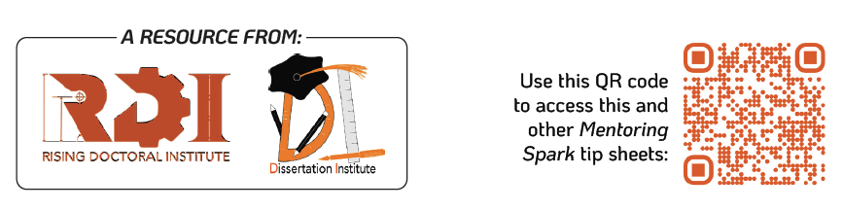

How Each Mentoring Spark is Organized

Each Mentoring Spark has the same set of sections.

- Solutions for Students: This section identifies the struggle point for students that this document addresses and high-level view of how it is addressed.

- Faculty FYI: This section introduces the overall topic and why faculty should care.

- Actions for Faculty: This section starts by reminding faculty to set a goal related to category/topic/level. It then includes some ideas on what conversations faculty might want to have with students. This section concludes with a goal setting prompt. Remember that SMART goals framework can be helpful and suggests that goals are specific, measurable, actionable, relevant, and time-bound.

- Digging Deeper: This section identifies potential tools that could be used relative to the category/topic/level.

- Exercises for Students: This section will identify activities faculty can guide students in completing.

- Reflection and Next Steps: This section is meant as guided self-reflection for the graduate student to identify what was helpful or not in this activity and/or how they will continue to move forward. Part of an advisor’s job is to help moderate graduate students' expectations and progress so helping them with a realistic self-reflection is important. This is intended as a conversation starter, for the students to think through actions needed to achieve their goal, and to help them balance their time and commitments. The section also includes a prompt for faculty to consider regarding how to help student’s continuing development.

Additional resources can be found on the website linked by URL or QR code on each Mentoring Spark.

